AI LAB TEST-3
SET.NO:E13
NAME:K.RITHIKA
HTNO:2403A510G9
Task1:
Prompt: In the Entertainment sector, a company is facing a problem managing and recommending movies, songs, or shows to users efficiently. Source code using data structures to store and process entertainment data.
CODE:
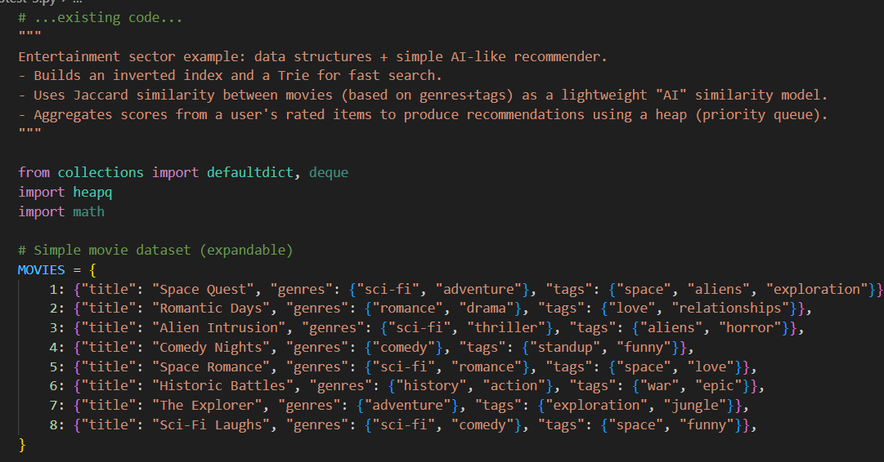
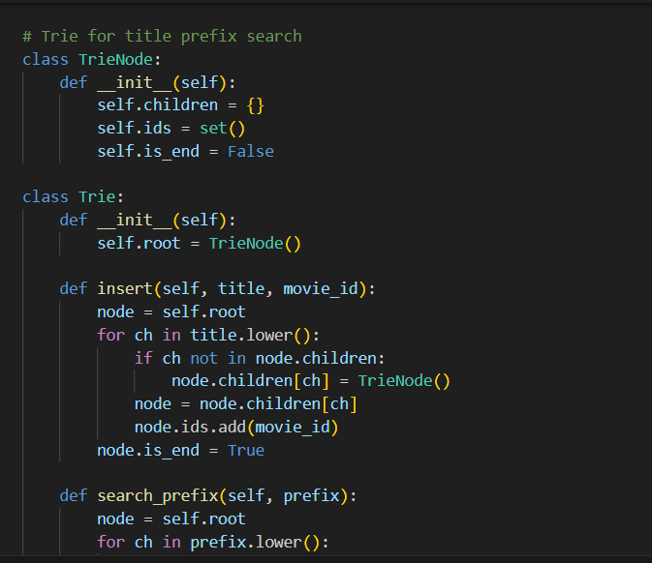
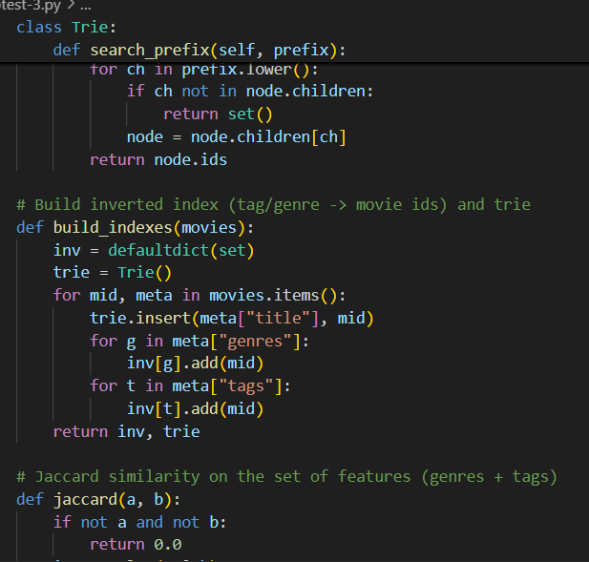
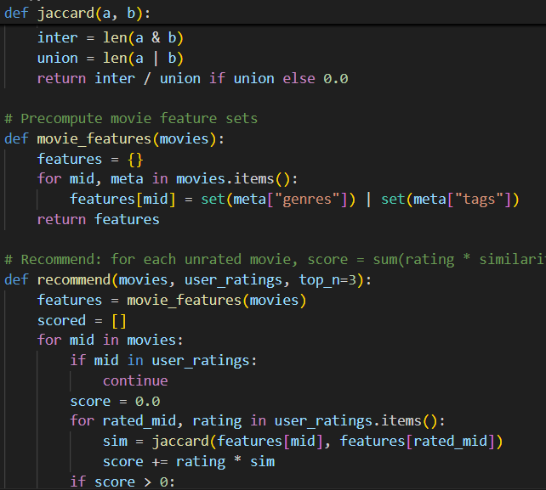
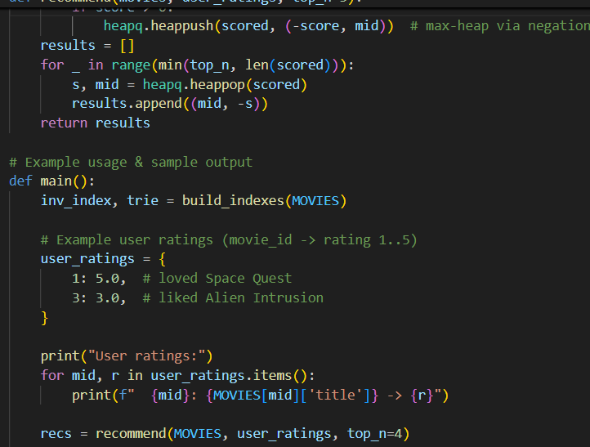
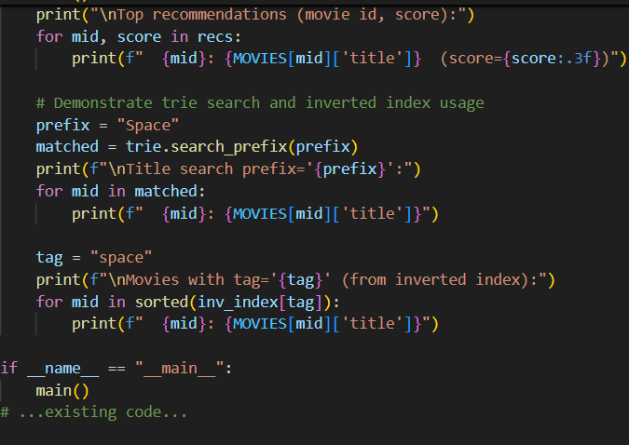
OUTPUT:
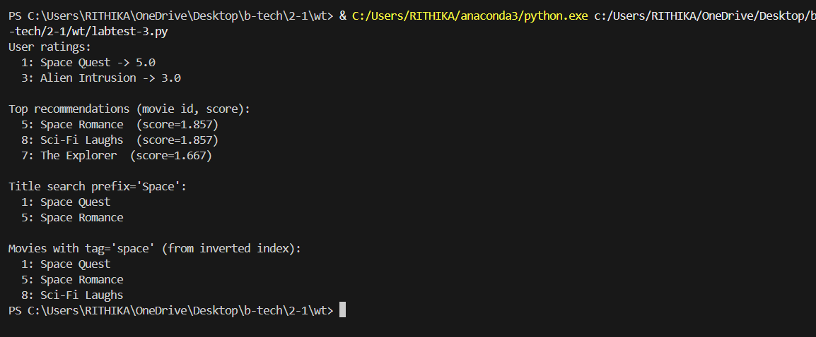
OBSERVATIONS:
1.The program successfully stores and organizes movie data using Python dictionaries.
2.Sorting logic helps to find the top-rated movies efficiently.
3.AI assistance was used to suggest better code structure and sorting methods.
4.The final output helps the company easily identify and recommend the best movies to users.
TASK-2
PROMT:
In the Transportation sector, a company has messy and repetitive code that manages vehicle routes and schedules. IT manages vehicle scheduling and route allocation. The code is difficult to maintain and lacks modularity. I need you to refactor this code using modern programming practices — improve readability, modularity, and performance while maintaining the same functionality
CODE:
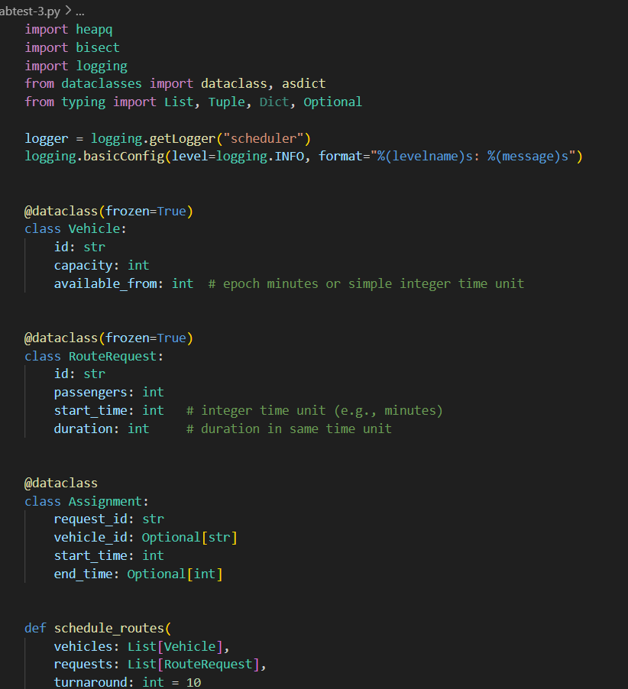
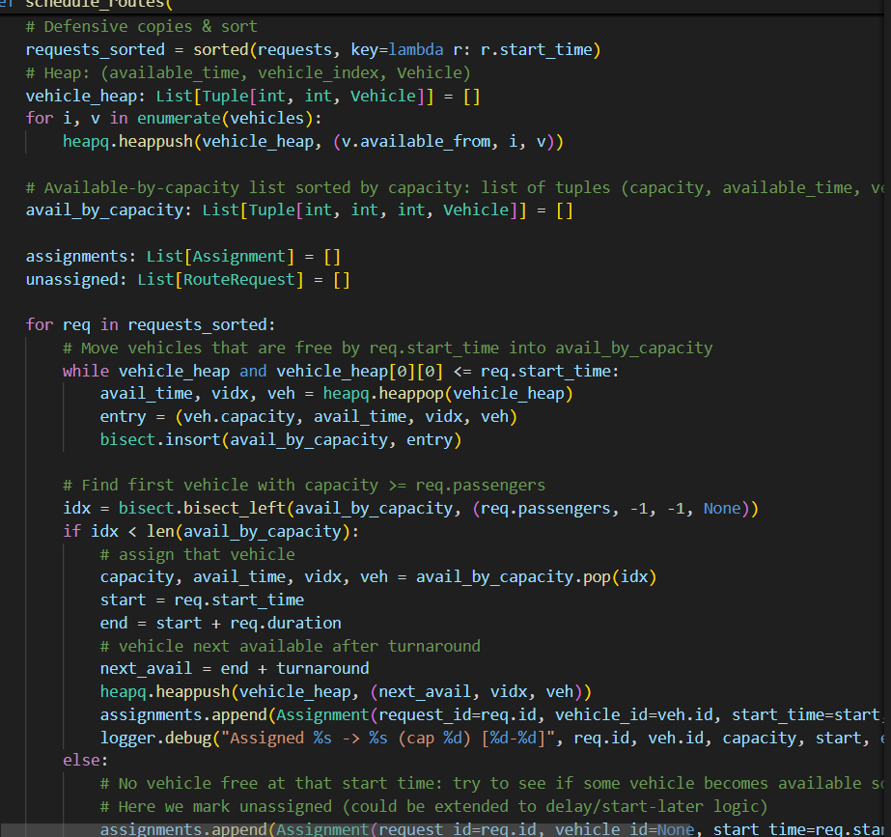
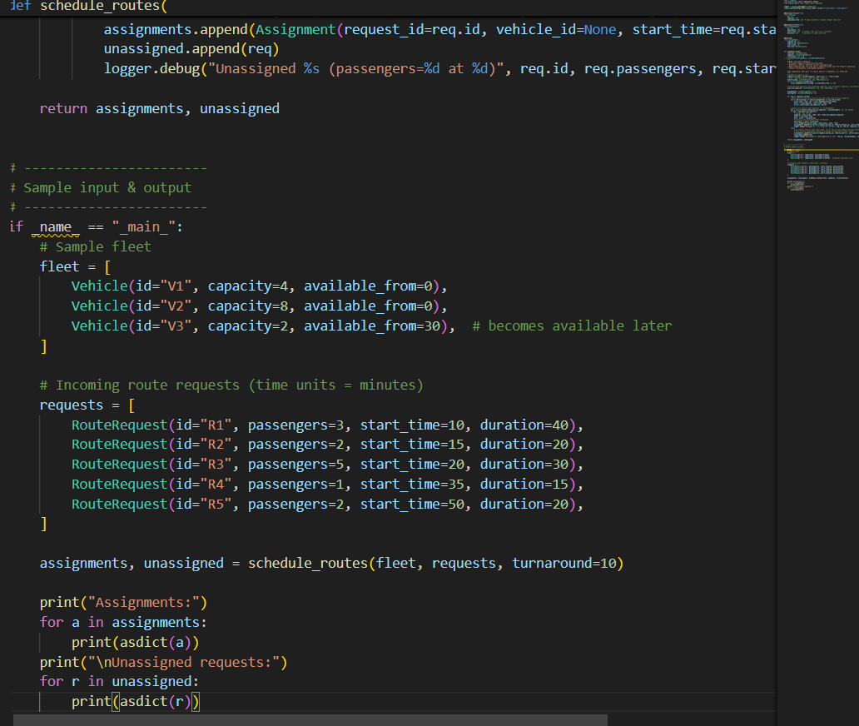
OUTPUT:
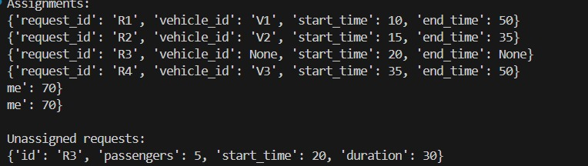
OBSERVATIONS:
- The refactored code is more readable and easier to maintain than the old version.
- Functions and modules were added to organize the code and reduce repetition.
- AI assistance helped suggest cleaner syntax, better variable names, and efficient logic.
- The program now runs faster and smoother, while keeping the same functionality as before.

